Do Voting Rules Reduce the Damage from Malicious AI Agents? A Simulation Study
Authors
Rong Jin <rongjin@kth.se>
Hieu Vu <hieuvtm@kth.se>
Abstract
Multi-agent LLM systems can contain a malicious insider: an agent that participates normally while covertly sabotaging the shared objective. This study asks whether the team's own collective decision rule limits the damage it does. We ran a controlled, pre-registered experiment in the open-source Among Us sandbox, where impostors deceive in pursuit of the game objective rather than on instruction. A 2×2 between-games design manipulated the vote threshold for ejection (plurality versus absolute majority) and the discussion protocol preceding it (free-form versus mandatory justification). In 80 games of five Claude Haiku 5.5 agents, twenty per condition, we analysed win rate and wrongful removal by logistic regression, damage by count models, and detection time by survival analysis. No effect survived correction for multiple testing. The threshold changed the outcome of only 5 of 76 votes, because most votes were unanimous or nearly so, and mandatory justification pointed, non-significantly, towards more wrongful removals rather than fewer. The study was powered for large effects only, so the results are inconclusive rather than evidence that governance has no effect.

Introduction

Background and Rationale
LLM agents are increasingly deployed in teams that divide a shared task and act on a common artefact such as a codebase or a plan. Their safety then depends on how the team behaves when one member does not share its goal. We study the malicious insider: an agent that participates normally while covertly sabotaging the objective. It needs no deliberate attacker, since deception can emerge from a model pursuing a goal [3], [4], and a compromised message can propagate adversarial instructions across a team [10].
Two defences exist. The first inspects the suspect agent through probes on internal activations, presupposing access a deployed team often lacks. The second changes the rules by which the team acts: what evidence must precede an accusation, and how many votes remove a member. We call this governance – cheap, model-agnostic, treating every agent as a black box. Every such rule cuts both ways. A permissive rule ejects the insider early but makes wrongful ejection easy; a strict rule protects innocents but leaves the insider in place longer; mandatory justification may raise evidence quality or merely give a deceiver a better stage. Which effect dominates cannot be settled by reasoning alone, yet an engineer configuring a multi-agent framework today must choose with no evidence base.

Theory and Related Work
Prior work. Distributed systems treat a decision threshold as a safety parameter: agreement holds only when faulty participants are bounded [1], [11]. That assumption does not transfer, since honest LLM agents are fallible reasoners whose votes are emergent judgements. Voting theory also predicts the threshold should matter, but sincere voting is not an equilibrium once voters reason strategically [9]. On deception, [3] and [4] show deception instrumental to a goal rather than instructed, and [2] carries this into the Among Us sandbox, extending AmongAgents [5] and finding deception easier to produce than to detect by white-box probes. AI control asks which protocol limits damage from a subversive model [6], but is hierarchical rather than peer-to-peer, and deliberation work [7], [8] assumes honest participants.
The gap. For a team with an undisclosed adversarial member and only black-box access, the collective decision procedure has not been treated as a manipulable independent variable, nor its effect measured against damage rather than detection. The sandbox closest to our setting [2] holds the voting phase fixed and excludes games in which the insider is never identified.

Research Problem, Aim, and Research Questions
Problem and aim. In a multi-agent LLM system with an undisclosed insider, the good agents know an insider may exist but not who it is. Existing work asks whether such deception can be detected, not which governance mechanism minimises the damage it inflicts. Within one fixed sandbox we measure how the removal threshold and the form of the discussion affect the damage caused by the insider and the rate of wrongful removal, holding model, task, team size and insider count constant.
Objectives. O1: by week 1, reproduce the sandbox and run three complete games with usable logs. O2: by week 2, implement a log parser extracting every dependent variable, validated at ≥ 95% field agreement against ten annotated transcripts. O3: by week 3, implement both governance factors as configuration options, with unit tests on the tally logic. O4: by week 3, pilot five games per condition and fix the run count and analysis plan. O5: by week 5, archive ≥ 20 valid games per condition. O6: by week 6, produce all pre-specified comparisons and five figures from one script.
Research questions. RQ1 (confirmatory): with one insider, how does the vote threshold (plurality versus an absolute majority of living agents) affect (a) the good-team win rate and (b) the damage absorbed? RQ2 (confirmatory): how does requiring a structured justification – an accusation with supporting evidence – before voting affect the rate of wrongful removal? RQ3 (secondary): how does each mechanism affect detection speed, measured as meetings until the insider is first correctly ejected, with never-ejected games right-censored?
Hypotheses. H1: an absolute majority reduces wrongful removal but increases damage absorbed, so the effect on the win rate is non-monotone. H2: requiring a justification lowers the wrongful-removal rate. H3 (exploratory): the factors interact, the benefit of justification being larger under plurality.
Scope. We manipulate governance only: one insider, constant team composition and model, no detection from model internals.

Research Method

Research Design and Methodological Rationale
Overall design. We run a controlled, quantitative experiment in an agent-based simulation: LLM agents play the game out turn by turn and we observe outcomes. The design is a 2×2 between-games factorial, with vote threshold and discussion protocol as independent variables. The unit of analysis is one complete game; because outcomes are stochastic, each condition is replicated many times. Everything else – model, decoding parameters, team size, insider count, map and task set, discussion rounds, step limit and all unmanipulated prompt text – is held fixed. The factorial design yields both main effects and tests H3.
Alternatives and assumptions. A game-theoretic treatment would have to fix the insider's strategy in advance, assuming away the emergent deception that makes the problem hard; qualitative analysis alone could not support a causal claim. We assume in-game destructive actions proxy damage to a shared objective. With one sandbox and one model, external validity is argued by analogy.

Data, Materials, Participants, or Other Sources
Simulation environment. The core material is the open-source Among Us sandbox released with [2], a public repository under CC0 1.0 [12]. It provides game logic, orchestration, agent prompting, per-game logging and evaluation scripts. Impostors map onto our insiders, crewmates onto the good agents. Play alternates between a task phase, in which the impostor fakes tasks and takes destructive actions, and a meeting phase, in which survivors discuss and vote.
Team configuration. The published configuration uses seven agents with two impostors; we use five with one insider. A single insider matches the threat model and avoids insider coordination as an uncontrolled factor. Five is the smallest team in which the thresholds can diverge after the first kill: divergence needs four living voters, since with three – and a skip vote counted as a ballot option (Table 1) – plurality already requires a majority. As a manipulation check we report the share of meetings in which re-tallying under the other threshold would change the decision. If week 1 shows this configuration is unsupported, we retain the published setup and report the changed prevalence as a limitation.
Model selection. A single commercial model, Claude Haiku 5.5 (claude-haiku-5-5), accessed exclusively through Anthropic's API, is held constant across conditions; no model weights are self-hosted. It replaces the GLM and DeepSeek shortlist of the research plan. The model accepts no sampling parameters such as temperature, so the decoding settings held fixed are its effort level (medium) and extended thinking (disabled); with thinking disabled, each agent's written reasoning is its only reasoning channel and is fully logged. The pilot checked the model against four criteria: cost per game within budget; latency low enough to finish in two weeks; coherent play (≥ 95% of votes and actions parsing into valid moves); and a baseline win rate inside [0.15, 0.85].
Units and sampling. One completed game is one experimental unit. Roles and tasks are drawn from a recorded seed; replicate k uses the same seed in all four conditions, so within a replicate only the rules differ, while roles vary across replicates. Conditions are interleaved rather than blocked, so drift in the hosted model affects all four equally. A game is excluded and regenerated if it aborts on an API error or if more than 5% of its turns cannot be read as a valid move. A reply is never guessed into a move: an unreadable reply is re-prompted once and then becomes a neutral turn (abstain, stay silent or stand still).
Table 1. Variables in the experiment.
Role | Variable | Definition and levels
Independent | Vote threshold | Plurality: most-voted agent ejected, ties resolved as no ejection. Absolute majority: more than half the living voters.
Independent | Discussion protocol | Free-form: the default discussion prompt. Justification: an accusation (named agent or abstention) plus one item of evidence.
Dependent | Good-team win | Binary; the game ends in a crew win.
Dependent | Damage absorbed | Count of the insider's successful destructive actions before the game ends.
Dependent | Wrongful removal | Binary per game (at least one good agent ejected) and count per game.
Dependent | Detection time | Meeting index at which the insider is first ejected; right-censored at game end.
Controlled | Fixed factors | Model, decoding parameters, team size, insider count, map and task set, discussion rounds, step limit, prompt text.
Recorded | Run metadata | Condition, seed, model identifier, timestamp, duration, token counts and cost.

Budget and ethics. Inference is bought through a hosted API and runs are parallelised on ordinary laptops. The pilot measures cost and latency, and the run count is set so spend stays inside a budget agreed with the mentor; if it cannot, Section 3.3 reduces the design rather than the replications. There are no human participants and no personal data, and we develop no new attack technique.

Work Procedure and Data Collection
Steps 1–2 – Reproduce and instrument (weeks 1–2). Clone the repository [12], install pinned dependencies, and run at least three complete games with the published configuration, recording the destructive actions available, the default voting code, whether team size is parameterised, and which fields the logs contain. Gate G1: if a full game cannot be completed by the end of week 1, we invoke risk R1. We then build a parser turning raw logs into three tables – per game, per meeting, per action. Gate G2: ≥ 95% field agreement with ten hand-annotated transcripts.
Step 3 – Implement the conditions (weeks 2–3). Both factors are configuration flags, not code edits. The threshold factor changes only the tally function, covered by unit tests on synthetic ballots checking ties, abstentions and the shrinking electorate. Players are also told which rule is in force, through texts of equal length for each threshold, since a rule the voters do not know could filter outcomes but not change how they argue or vote. Skip is an explicit ballot option, and the result of every vote is announced to the surviving players. The discussion factor changes only the instruction text before the final discussion round, plus a format check that re-prompts once if a statement has no parseable accusation and evidence. The free-form condition receives a length-matched neutral instruction, so prompt length is not confounded.
Steps 4–5 – Pilot and freeze the plan (week 3). Run five games per condition. The pilot delivers the model choice, variance estimates, and cost and time per game. From these we set runs per condition: a floor of 15, a planned 20, a target of 30. Gate G3: sanity checks pass and projected cost is inside budget. Before any main-experiment game is run, the analysis script, test list, exclusion criteria and damage weights are committed and tagged; anything computed afterwards is exploratory.
Steps 6–8 – Run, analyse and package (weeks 4–6). All four conditions run interleaved, one recorded seed per game, with automatic retry on transient API failure. The frozen script then produces the tests and figures in Section 2.4. In parallel, a qualitative sub-study explains mechanism: twenty meetings ending in the ejection of a good agent are sampled across conditions and coded independently by both authors. On completion we tag a reproducibility package with dependencies, seeds, logs, parsed tables, the script and a README.

Data Analysis and Quality Assurance
Operational definitions. Per game we record: the outcome, a good-team win or not; damage absorbed, a count of the insider's successful destructive actions, combined into a pre-specified equally weighted composite fixed before the pilot (killing is the only destructive action implemented in the sandbox, so damage equals the insider's kill count); wrongful removal, true if at least one good agent is ejected; detection time, the meeting index at which the insider is first ejected, right-censored at game end; and exposure, the task rounds the insider survives, used as the count-model offset.
Confirmatory analysis. All confirmatory tests are two-sided at α = 0.05 and Holm-corrected; effect sizes and 95% confidence intervals are reported for every comparison and are what we interpret. Binary outcomes use logistic regression: main effects come from a model with both factors, and the interaction (H3) from a second model that adds their product, since with treatment coding the lower-order terms of an interaction model are effects at the reference level of the other factor rather than main effects. Damage uses negative binomial regression with a log-exposure offset, replaced by Poisson regression with robust standard errors when the counts show no overdispersion. Detection time uses Kaplan–Meier and a Cox model; censoring never-detected games is deliberate, since conditioning on correct ejections would select the games in which governance worked.
Table 2. Mapping from research questions to metrics, tests and planned figures.
Question | Metric | Planned test | Figure
RQ1a | Good-team win rate | Logistic regression (threshold × protocol); Fisher's exact per cell | F1: win rate by condition with 95% CI
RQ1b | Damage absorbed | Negative binomial GLM with log-exposure offset; Mann–Whitney with Cliff's delta | F2: damage by condition; F3: cumulative damage against round
RQ2 | Wrongful-removal rate | Logistic regression; two-proportion test with risk difference and 95% CI | F4: wrongful-removal rate by condition
RQ3 | Meetings to first correct ejection | Kaplan–Meier with log-rank test; Cox proportional hazards | F5: Kaplan–Meier detection curves by condition
H3 | All primary outcomes | Interaction term in the regressions above | F1, F4, grouped by both factors

Decision rules. H1 is supported if the threshold effect gives fewer wrongful removals and more damage under absolute majority while the win-rate interval includes zero or reverses sign across the other factor; it is contradicted if the win rate rises monotonically with the threshold. H2 is supported if the justification coefficient gives an odds ratio below one with an interval excluding one; H3 is supported if the interaction term's interval excludes zero in the predicted direction, which with plurality and free-form as reference levels is a positive product term. In every case a direction counts only if its interval excludes no effect and its Holm-adjusted p-value is below 0.05.
Statistical power. At 20 games per condition a main-effect comparison pools 40 games per level and detects a win-rate difference of about 29 percentage points with 80% power at α = 0.05 against a baseline of 0.5; at 30 games it detects about 25, and a single cell-to-cell comparison about 33. The study is powered for large effects only, so a non-significant comparison is inconclusive rather than evidence of no effect.
Threats to validity. Internally, the manipulated prompt differs in length as well as content, addressed by the length-matched filler, and the hosted model may change during the runs, addressed by interleaving conditions and recording the model identifier per game. Destructive actions proxy real harm and the composite depends on chosen weights, so component counts are reported separately. All findings come from one sandbox and model, so conclusions concern a mechanism rather than deployment.
Quality assurance. Randomised roles and interleaved conditions guard against assignment effects, and replication is the central control on stochasticity. Because LLM sampling means a run cannot be reproduced token for token even at fixed seed, we treat the raw logs as the primary record: the analysis is reproducible from archived logs even where the generation is not. Qualitative codes are double-coded with Cohen's κ reported.

Use of AI Tools
We distinguish the LLM that is the object of study – whose outputs are data, never claims – from the assistants we use as instruments. Coding assistants will draft the parser, tests and plotting code, but no generated code is committed unread: every change is reviewed line by line by the author who did not prompt for it. LLM-based search triages papers, but no source enters the reference list unless an author has read it. AI tools improve grammar and clarity only. Both authors take full responsibility for the intellectual content.

Results

Pilot and Final Configuration
Pilots. Two pilots of five games per condition preceded the main experiment, and all 40 games were valid. The first used three tasks per crewmate (one common, one short, one long) and a kill cooldown of three timesteps. Every turn parsed into a valid move and 65% of games held a meeting, but the crew won all five baseline games (19 of 20 overall): 17 games ended with the crew completing its tasks, after a median of 13 of 30 timesteps, before the insider could do much damage, so gate G3 failed. The second pilot raised the task load to five per crewmate (two common, two short, one long) and shortened the kill cooldown to two timesteps, in all conditions alike. The crew then won three of five baseline games (16 of 20 overall), 65% of games held a meeting, and all three checks passed. The pilots cost USD 0.43 and 0.49, and their games are not used in the analysis.
Freeze. The second pilot's configuration became the study preset. The analysis script, confirmatory tests, exclusion rule, damage weights and game settings were then committed and tagged prereg-v1 before any main-experiment game was played; the main run records that commit and an unmodified working tree.
Departures from the plan. Besides the model (Section 2.2), the implementation departs from the plan in five documented ways. Players are told which voting rule is in force, since a rule voters do not know cannot change how they argue (Section 2.3). Replicates share seeds across conditions instead of drawing roles independently per game, which blocks on the starting position; the planned tests ignore this blocking, which makes them conservative rather than invalid. Damage reduces to the kill count, because the sandbox's sabotage action is not implemented. Verdicts require the Holm-adjusted test as well as the interval (Section 2.4). Finally, kill counts of zero to three showed no overdispersion, so the count models used Poisson regression with robust standard errors rather than the negative binomial.

Data Quality and Outcomes by Condition
Data quality. All 80 scheduled games were valid and none was regenerated. Of 5,793 decisions, all but two were read as a valid move (99.97%), and no agent refused to play. Under the justification protocol, 96% of final-round statements met the required format. The run cost USD 2.25, or 222 seconds, 73 model calls and USD 0.028 per game. [Gate G2, agreement between ten hand-annotated transcripts and the parsed metrics, is still to be reported.]
Game outcomes. The crew won 67 of 80 games (84%): 44 by completing its tasks and 23 by ejecting the insider. The insider won the other 13 by outnumbering the crew, and no game reached the time limit; games lasted a median of 15.5 timesteps. In 62 games (78%) at least one meeting reached a vote, 0.95 meetings per game on average. Table 3 gives the outcomes by condition.
Baseline and manipulation checks. In the baseline condition (plurality, free-form) the crew won 19 of 20 games (95%), above the range [0.15, 0.85] that the pilot gate required; the second pilot's estimate of 60% rested on five games. The baseline therefore sits near the ceiling, which leaves little room to show a rule that improves the crew's outcome. No game was excluded on this basis, since the exclusion rule concerns only whether a game ran properly. Re-tallying each vote under the other threshold would have changed the decision in 5 of 76 meetings (7%, 95% CI [3%, 14%]). The agents mostly voted together: 24 votes were unanimous and 39 had a single dissenter, and on such votes the two thresholds agree.
Table 3. Outcomes by condition in the main experiment, 20 games each. Proportions with 95% Wilson intervals.
Condition | Crew win | Wrongful removal | Insider ejected | Kills per game (mean) | Meetings per game (mean)
Plurality, free-form | 95% [76, 99] | 5% [1, 24] | 35% [18, 57] | 1.40 | 1.20
Plurality, justification | 85% [64, 95] | 15% [5, 36] | 20% [8, 42] | 1.25 | 0.65
Majority, free-form | 75% [53, 89] | 5% [1, 24] | 20% [8, 42] | 1.60 | 0.90
Majority, justification | 80% [58, 92] | 20% [8, 42] | 40% [22, 61] | 1.45 | 1.05

Confirmatory Tests
Threshold and protocol (RQ1, RQ2, H3). None of the four confirmatory tests survived the Holm correction (Table 4), so by the decision rules of Section 2.4 all three hypotheses are inconclusive. Under an absolute majority the crew won 77.5% of games against 90% under plurality, and the insider killed 1.53 crewmates per game against 1.33 (Figures 1–3). The damage difference points in the direction H1 predicts, but wrongful removal was not lower under majority (12.5% against 10%), and no interval excludes no effect. Mandatory justification went with more wrongful removals, 17.5% against 5%, the opposite of H2, with an odds ratio of 4.04 whose interval [0.78, 20.83] includes one (Figure 4). For H3, the interaction term for wrongful removal has an odds ratio of 1.42 with an interval of [0.05, 37.85].
Detection (RQ3). Detection speed did not differ clearly by either factor (Figure 5). In the Cox model the hazard ratio was 1.05 [0.45, 2.46] for majority and 1.45 [0.62, 3.38] for justification, and the log-rank tests gave p = 0.76 and p = 0.34. Of the 23 insiders ejected, 20 went at the first meeting that reached a vote.
Table 4. Confirmatory tests, two-sided, Holm-corrected as one family. OR odds ratio, RR rate ratio; brackets are 95% confidence intervals.
Test | Outcome | Contrast | Effect [95% CI] | p | p (Holm)
RQ1a | Good-team win | Majority vs plurality | OR 0.38 [0.11, 1.36] | 0.139 | 0.416
RQ1b | Damage absorbed (kills) | Majority vs plurality | RR 1.14 [0.88, 1.47] | 0.327 | 0.654
H1 | Wrongful removal | Majority vs plurality | OR 1.30 [0.31, 5.39] | 0.719 | 0.719
RQ2 | Wrongful removal | Justification vs free-form | OR 4.04 [0.78, 20.83] | 0.095 | 0.381

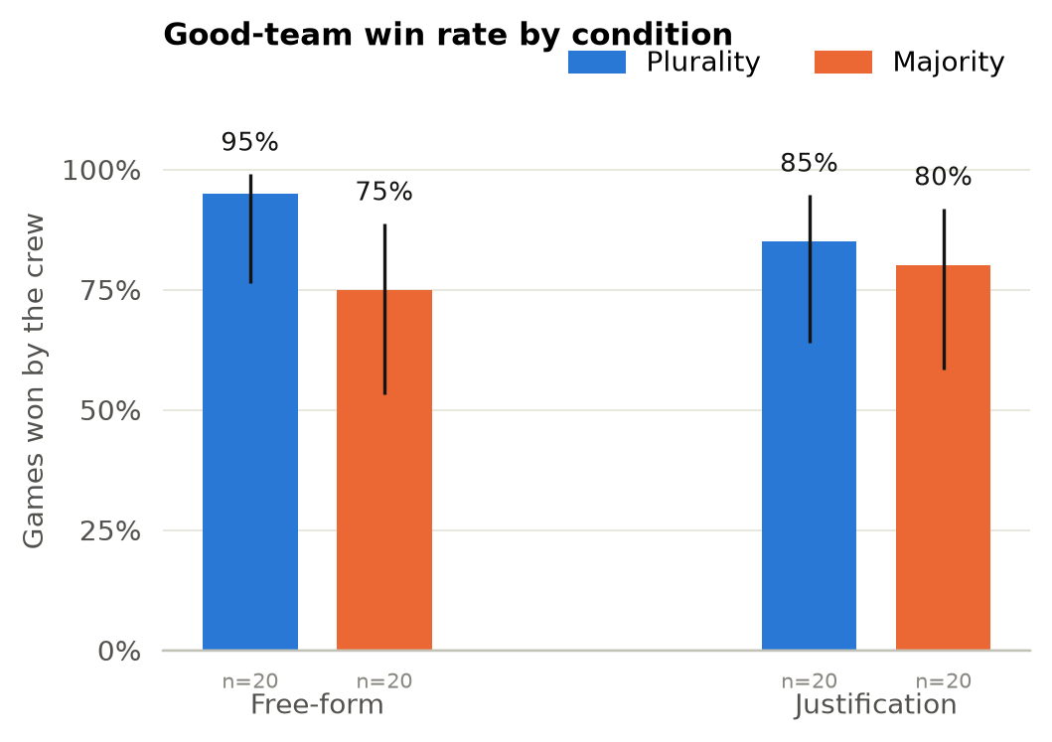
Figure 1 (F1). Good-team win rate by condition, with 95% Wilson intervals.
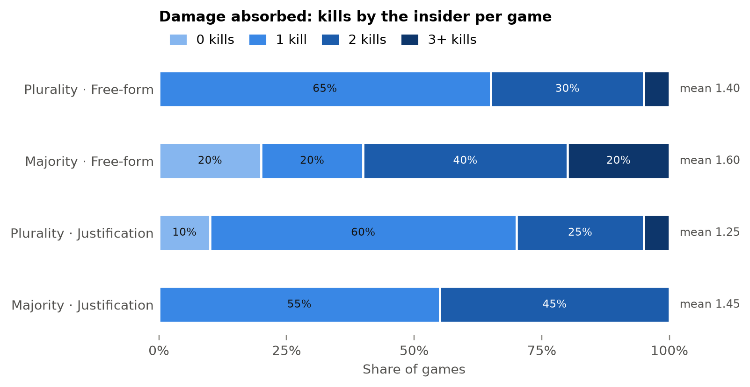
Figure 2 (F2). Damage absorbed: distribution of the insider's kills per game by condition.
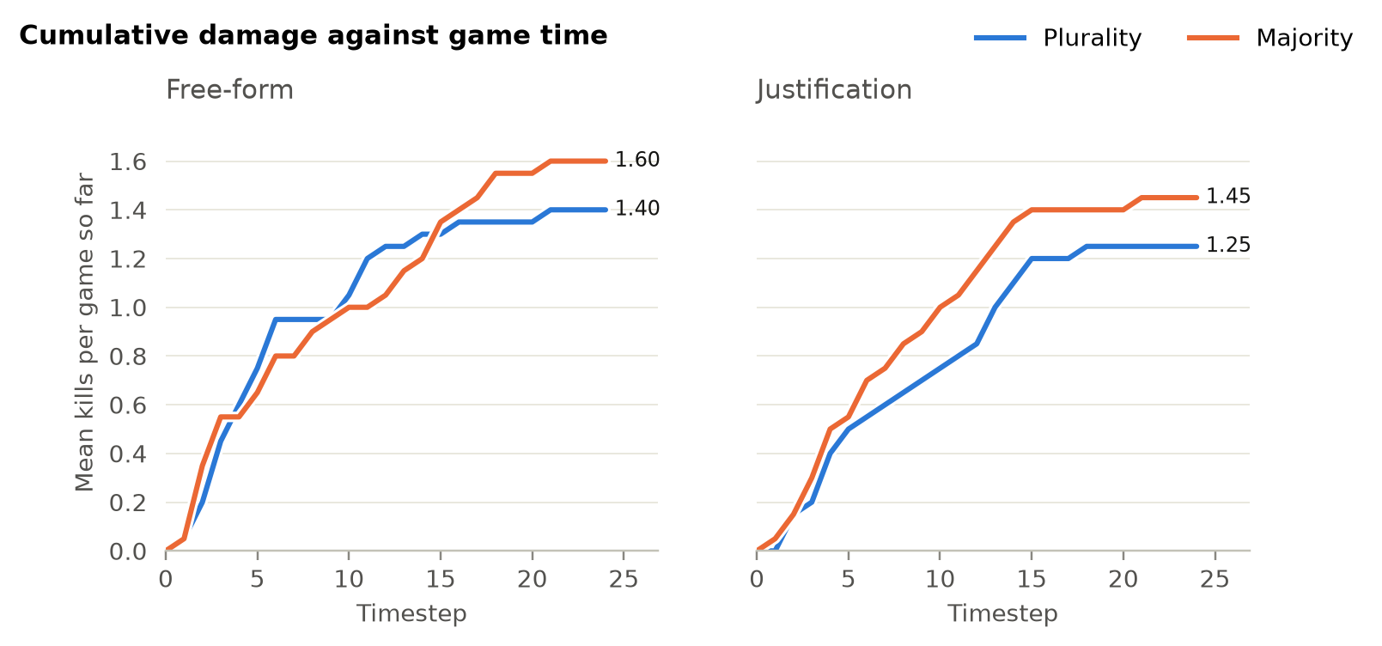
Figure 3 (F3). Cumulative damage: mean kills per game against game time, by threshold and protocol.
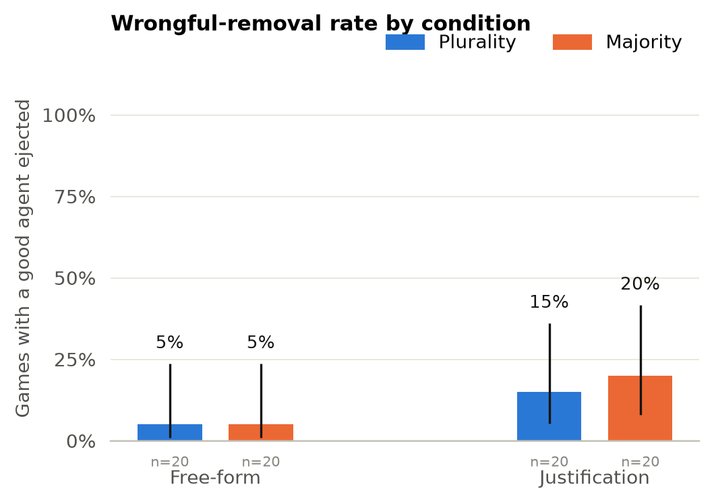
Figure 4 (F4). Wrongful-removal rate by condition, with 95% Wilson intervals.
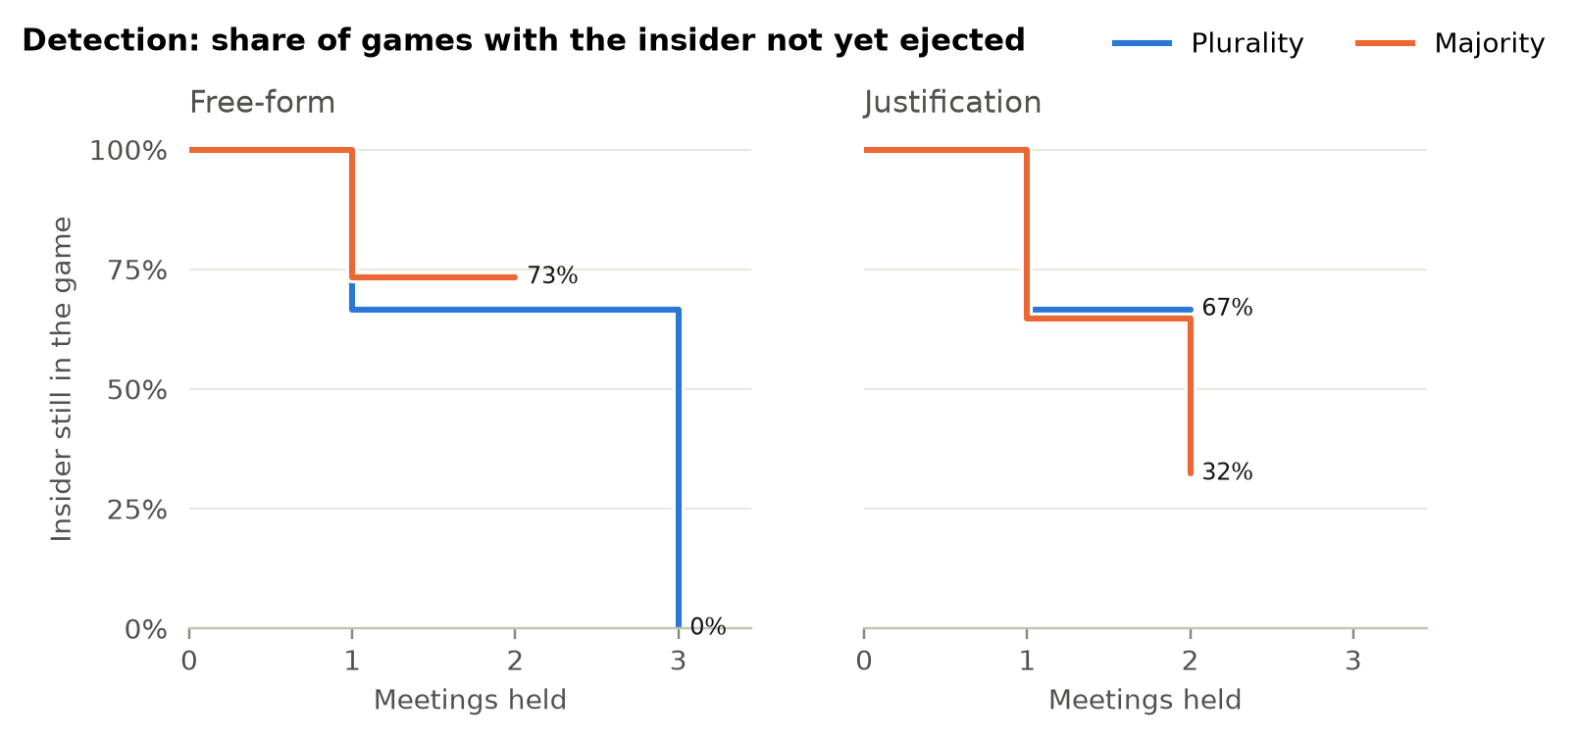
Figure 5 (F5). Detection: Kaplan–Meier share of games with the insider not yet ejected, by meetings held. Few games reach a third meeting, so the late steps rest on one or two games.

Exploratory Observations
Votes the threshold decided. Four of the five meetings in which the threshold mattered fell in the majority–justification condition. In them the majority rule blocked the ejection of the insider twice and of an innocent agent twice; in the fifth, plurality ejected an innocent agent where a majority would have blocked it. This is the trade-off H1 describes, but five cases cannot establish it.
Wrongful ejections. The main run produced 10 wrongful ejections in 9 games, 8 of them under the justification protocol. Whether the required accusation line leads agents to name a suspect on weak evidence is the first question for the qualitative sub-study, which codes all ten rather than the twenty the plan anticipated. [Codebook, coded sample and Cohen's κ to be added.]

Discussion

Interpretation and Answers to the Research Questions
RQ1. Neither part of RQ1 has a clear answer. Under an absolute majority the good team won less often (77.5% against 90%) and absorbed slightly more damage (1.53 against 1.33 kills per game), but both intervals include no effect (Table 4, Figures 1–3). The manipulation check explains part of this: the threshold changed the decision in only 5 of 76 meetings, because agents in a five-member team mostly voted together. A threshold that rarely binds has little opportunity to matter, so the null result says more about this configuration than about thresholds in general.
RQ2. Mandatory justification did not lower the wrongful-removal rate. The point estimate runs the other way, from 5% to 17.5%, but its interval is wide and the effect does not survive correction, so H2 is neither supported nor contradicted. If the direction is real, a required accusation may push agents to name someone on thin evidence, which the qualitative sub-study is designed to examine.
RQ3. Detection speed did not differ clearly by either factor (Figure 5): insiders that were caught were mostly caught at the first meeting, whatever the rules.
H3. The interaction cannot be assessed at this sample size; its interval for wrongful removal spans more than two orders of magnitude.
Overall. The study found no detectable effect of either governance factor. This is not evidence that the factors have no effect: with twenty games per condition only large differences were detectable (Section 2.4), and the baseline crew win rate of 95% left little room for a rule to help the good team.

Validity, Limitations, and Generalizability
Internal validity. The manipulated prompt differs in length as well as content; the length-matched neutral instruction in the free-form condition addresses this. The hosted model may change during the runs; interleaving conditions and recording the model identifier per game spreads any drift across all four conditions.
Construct validity. Destructive in-game actions are a proxy for real harm to a shared objective, so damage is reported both in total and per action type rather than only as one number. The manipulation check shows whether the threshold factor actually changed decisions; if it rarely did, a null result for RQ1 says little about thresholds in general. In the main run the threshold changed the decision in 5 of 76 meetings (7%; Section 3.2), and the RQ1 results should be read in that light.
Statistical conclusion validity. With 20–30 games per condition, only large effects are detectable (Section 2.4). Non-significant comparisons are inconclusive, not evidence that a rule has no effect. The baseline condition also ended near the ceiling, with the crew winning 95% of games, which limits how much any rule could raise the good team's win rate.
External validity. All findings come from one sandbox, one model and one team size, so conclusions concern a mechanism rather than deployment. Real multi-agent systems differ in task structure, in how removal works, and in how long agents interact. In practice the five-agent configuration held, but two pilots were needed to tune the task load and kill cooldown, and the main run's baseline still fell outside the range the pilot gate required. Damage reduces to the kill count, since the sandbox implements no other destructive action, and the qualitative sub-study rests on ten wrongful ejections rather than twenty.

Ethics, Societal Aspects, and Sustainability
Ethics. The study has no human participants and uses no personal data; all subjects are LLM agents in an open-source CC0 sandbox, and we develop no new attack technique. A possible dual-use concern is that evidence on which governance rules fail could inform an adversary. We judge this risk low, since the rules studied are standard, publicly documented configuration choices, and an evidence base for safer defaults benefits defenders more than attackers.
Societal aspects. Engineers already choose voting and escalation rules when configuring multi-agent frameworks, currently without evidence. Our results can inform that choice, but given the limitations above they should be read as evidence about a mechanism, not as a recommendation for any production system.
Sustainability. Every game consumes hosted inference. We record tokens per game (Table 1), which allows the total compute to be reported: approximately 21.9 million tokens over 120 games, of which the main run's 80 games used 15.5 million and the two pilots the rest, at a total cost of USD 3.17. The run count is sized to the smallest design that supports the confirmatory tests rather than over-replicating, and the archived logs let others reanalyse the data without re-running the games.

  - Implications and Future Work
Implications. If H1 holds, no threshold is safe by default: a strict threshold trades insider damage for fewer wrongful removals, and the right choice depends on which of the two costs more in a given system. If H2 holds, requiring evidence before an accusation is a cheap, model-agnostic safeguard that a framework could enable by default. If neither factor has a detectable effect, governance alone is a weak lever at this team size, and black-box rules would need to be combined with other defences. Our results fall in this last case, with the caveat that only large effects were detectable. The direction of the justification effect is a further caution: a mandatory accusation may cost innocent agents as well as constrain a deceiver, so it should not be enabled by default without evidence that it helps.
Future work. A natural next step is to add several insiders, to test whether coordinated insiders defeat thresholds that work against a single one, and to repeat the experiment with other models and larger teams to see how far the effects generalise. Black-box governance could also be combined with white-box probes, so that a probe signal becomes evidence in the justification step. Finally, moving from game actions to a collaborative task with a measurable artefact, such as a shared codebase, would bring the damage measure closer to real harm.
5 Conclusion
We tested whether a team's own decision rules limit the damage done by an undisclosed malicious agent, in a pre-registered experiment of 80 games with five Claude Haiku 5.5 agents in the Among Us sandbox. Neither an absolute-majority threshold nor a mandatory justification had a detectable effect on the good team's win rate, the damage absorbed, the wrongful-removal rate or detection speed once the confirmatory tests were corrected for multiple testing. The threshold rarely decided a vote, because agents mostly voted together, and mandatory justification pointed, without statistical support, towards more wrongful removals rather than fewer. Governance rules of this kind are cheap and model-agnostic, but at this team size any effect they have is smaller than a study of this size can detect; larger samples and settings with genuinely contested votes are needed before they can be recommended.
References
[1] L. Lamport, R. Shostak, and M. Pease, “The Byzantine Generals Problem,” ACM Transactions on Programming Languages and Systems, vol. 4, no. 3, pp. 382–401, Jul. 1982.
[2] S. Golechha and A. Garriga-Alonso, “Among Us: A Sandbox for Measuring and Detecting Agentic Deception,” in Advances in Neural Information Processing Systems (NeurIPS), 2025. arXiv:2504.04072.
[3] E. Hubinger, C. Denison, J. Mu, M. Lambert, M. Tong, M. MacDiarmid, T. Lanham, D. M. Ziegler, T. Maxwell, N. Cheng, et al., “Sleeper Agents: Training Deceptive LLMs that Persist Through Safety Training,” arXiv:2401.05566, 2024.
[4] R. Greenblatt, C. Denison, B. Wright, F. Roger, M. MacDiarmid, S. Marks, J. Treutlein, T. Belonax, J. Chen, D. Duvenaud, et al., “Alignment Faking in Large Language Models,” arXiv:2412.14093, 2024.
[5] Y. Chi, L. Mao, and Z. Tang, “AmongAgents: Evaluating Large Language Models in the Interactive Text-Based Social Deduction Game,” arXiv:2407.16521, 2024.
[6] R. Greenblatt, B. Shlegeris, K. Sachan, and F. Roger, “AI Control: Improving Safety Despite Intentional Subversion,” in Proceedings of the 41st International Conference on Machine Learning (ICML), PMLR vol. 235, 2024.
[7] Y. Du, S. Li, A. Torralba, J. B. Tenenbaum, and I. Mordatch, “Improving Factuality and Reasoning in Language Models through Multiagent Debate,” in Proceedings of the 41st International Conference on Machine Learning (ICML), PMLR vol. 235, 2024.
[8] Y. Xu, S. Wang, P. Li, F. Luo, X. Wang, W. Liu, and Y. Liu, “Exploring Large Language Models for Communication Games: An Empirical Study on Werewolf,” arXiv:2309.04658, 2023.
[9] D. Austen-Smith and J. S. Banks, “Information Aggregation, Rationality, and the Condorcet Jury Theorem,” American Political Science Review, vol. 90, no. 1, pp. 34–45, 1996.
[10] D. Lee and M. Tiwari, “Prompt Infection: LLM-to-LLM Prompt Injection within Multi-Agent Systems,” arXiv:2410.07283, 2024.
[11] M. Castro and B. Liskov, “Practical Byzantine Fault Tolerance,” in Proceedings of the 3rd USENIX Symposium on Operating Systems Design and Implementation (OSDI), New Orleans, LA, USA, 1999, pp. 173–186.
[12] S. Golechha and A. Garriga-Alonso, “AmongUs: sandbox, game logs and probes,” GitHub repository, CC0 1.0. [Online]. Available: https://github.com/7vik/AmongUs. Accessed: Sep. 2026.
Appendices
Appendix A. Condition specification. The exact prompt text for each condition, the tally pseudocode for both thresholds, and the codebook for the qualitative sub-study will be fixed at the end of week 3 and included in the final report.

